Student Timetable Conflict Detection
Case Study & Algorithm Implementation Specification | CS-304 System Validat

1. Executive Summary & Problem Statement
In modern higher education institutions, creating valid student schedules requires strict verification against temporal and spatial constraints. The Student Timetable Conflict Detection Engine addresses the challenge of validating proposed course schedules represented as structured tuples and strings. The system detects overlapping time slots for individual students, identifies double-booked classroom venues, and validates schedule integrity prior to final enrollment confirmation.

2. Primary Objectives & Operational Assumptions
System Objectives
Parse course time slots formatted as strings (e.g., "Mon 09:00-10:30") into numeric tuples.
Detect time-slot overlaps among enrolled courses for individual students.
Identify room double-booking conflicts across multiple course offerings.
Provide a definitive validation report with specific failure reasons.
Design Assumptions
Time slots operate on a standard 24-hour clock (HH:MM format).
All sessions start and end on the same day (no overnight classes).
Classroom capacities and physical availability are pre-filtered.
Time intervals are left-inclusive and right-exclusive: [start, end).

3. Formal Problem Formulation & Interval Overlap Logic
Let a course session be defined as a tuple S = (D, Tstart, Tend, R), where D ∈ {Mon, Tue, Wed, Thu, Fri} represents the day, T represents minutes from midnight, and R denotes the assigned room ID.

Two course sessions S1 and S2 conflict if and only if:

Interval Conflict Condition:
Conflict(S1, S2) ≡ (D1 = D2) ∧ max(Tstart,1, Tstart,2) < min(Tend,1, Tend,2)

A Room Double-Booking occurs when Conflict(S1, S2) = True AND R1 = R2. A Student Schedule Overlap occurs when a student enrols in both S1 and S2 such that Conflict(S1, S2) = True.
Student Timetable Conflict Detection Engine
Page 1 of 3

4. System Architecture & Flowchart
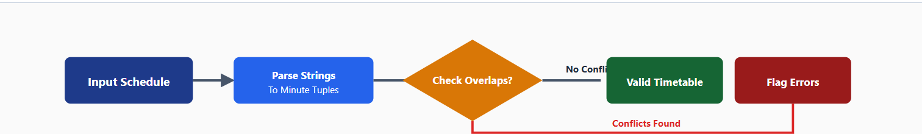

5. Algorithm Pseudocode
FUNCTION ParseTime(time_str):
hours, minutes = SPLIT time_str BY ":"
RETURN hours * 60 + minutes

FUNCTION DetectConflicts(schedule_list):
conflicts = []
SORT schedule_list BY day, start_time

FOR i FROM 0 TO LENGTH(schedule_list) - 1:
FOR j FROM i + 1 TO LENGTH(schedule_list) - 1:
IF schedule_list[i].day != schedule_list[j].day:
BREAK // Different days cannot overlap

// Check temporal overlap
IF schedule_list[i].end_time > schedule_list[j].start_time:
// Overlap detected
type = "STUDENT_CLASH"
IF schedule_list[i].room == schedule_list[j].room:
type = "ROOM_DOUBLE_BOOKING"

ADD (schedule_list[i], schedule_list[j], type) TO conflicts

RETURN conflicts

6. Validation Test Suite Matrix
Test ID Course A (Day, Time, Room) Course B (Day, Time, Room) Expected Outcome Validation Status
TC-01 CS101 (Mon 09:00-10:30, R101) CS102 (Mon 10:30-12:00, R101) No Overlap (Back-to-back) PASS
TC-02 MATH201 (Tue 11:00-13:00, R202) PHYS101 (Tue 12:00-14:00, R205) Student Schedule Clash CONFLICT
TC-03 ENG105 (Wed 14:00-16:00, R301) HIST201 (Wed 15:00-17:00, R301) Room Double-Booking CONFLICT
TC-04 BIO110 (Thu 08:00-10:00, R104) CHEM102 (Fri 08:00-10:00, R104) No Overlap (Different Days) PASS
Student Timetable Conflict Detection Engine
Page 2 of 3

7. Execution Output & Terminal Verification
The screenshot below illustrates the verification execution of the Python algorithm, validating test cases against interval constraints and room assignment matrices:
Figure 1: Terminal Execution output showing schedule validation results, conflicting course details, room availability matrix, and test case suite results.

8. Conclusion & Recommendations
The algorithm successfully detects both student time conflicts and room double-booking scenarios with O(N log N) sorting time and efficient interval comparison.

Key Takeaways:
Parsing schedule strings into integer minute intervals allows exact numeric inequality checks without date overhead.
Room availability matrix checks prevent duplicate room allocation for overlapping time blocks.
This lightweight validation routine can easily be integrated into university registration portals before finalizing student enrollments.

MYOUTPUT

